

JENKINS CI AND CD PIEPLINE
AGENDA
- CONTINUOUS INTEGRATION AND CONTINUOUS DELIVERY.
- JENKINS PIPELINE.
- HOW MANY WAYS WE CAN CREATE PIPELINE?
- CREATE JENKINS PIPELINE USING GROOVY SCRIPT / JENKINS FILE.

CONTINUOUS INTEGRATION AND CONTINUOUS DELIVERY:
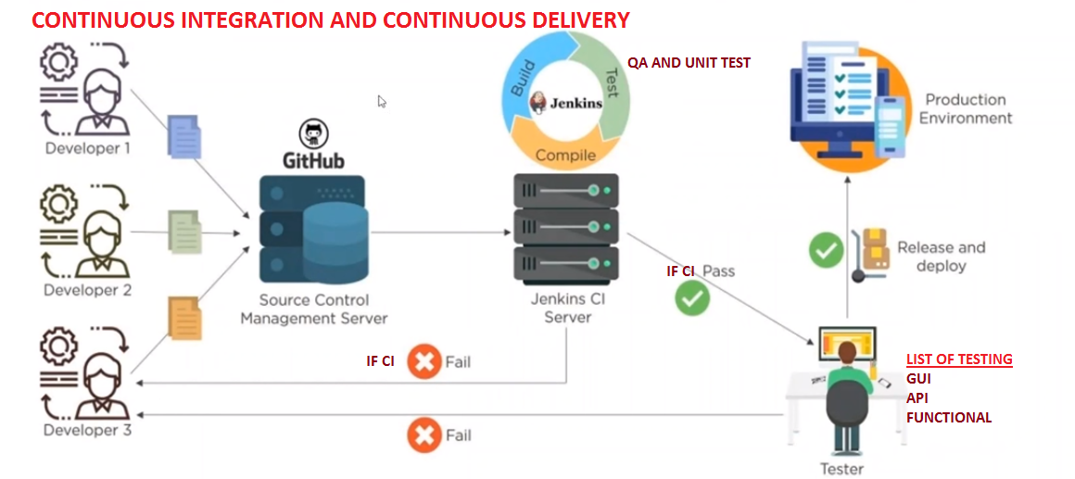

JENKINS PIPELINE:
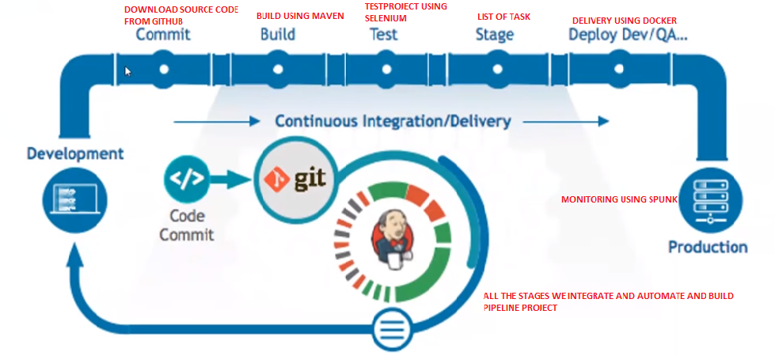



HOW MANY WAYS WE CAN CREATE A PIPELINE?
- USING BUILD AND DELIVERY PIPELINE PLUG-INS
- USING GROOVY SCRIPT ON THE FLY(HERE WE USE JENKINS FILE)
- SCRIPTED PIPELINE
- DECLARATIVE PIPELINE

DIFFERENCE BETWEEN PLUG-IN AND GROOVY PIPELINE
PLUG-IN PIPELINE | GROOVY PIPELINE
Difficult to link and automate multiple sub-jobs | Easy to Link and Automate Multiple staged sub-jobs whenever we need
Portable for simple - Project | Portable for any type of - Projects
In Single pipeline we can integrate all jobs sequentially and run | With one single pipeline we can automate all stages through groovy script
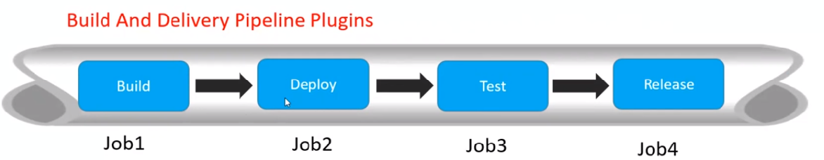 | 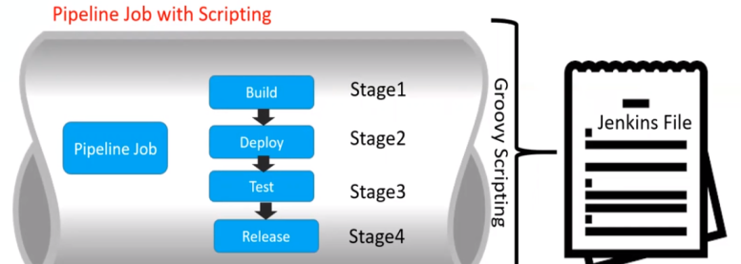

CREATE JENKINS PIPELINE USING GROOVY SCRIPT / JENKINS FILE
SCRIPTED PIPELINE:
CREATE AN NEW ITEM:
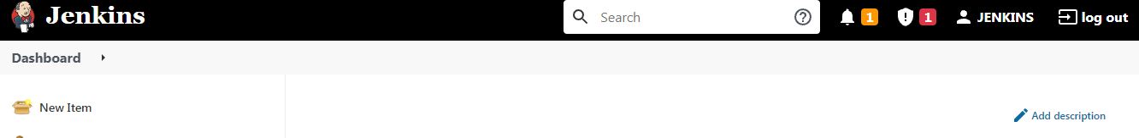

NAME THE JOB: Jenkins-Scriptedpipeline
SELECT THE CONFIGURATION: Pipeline
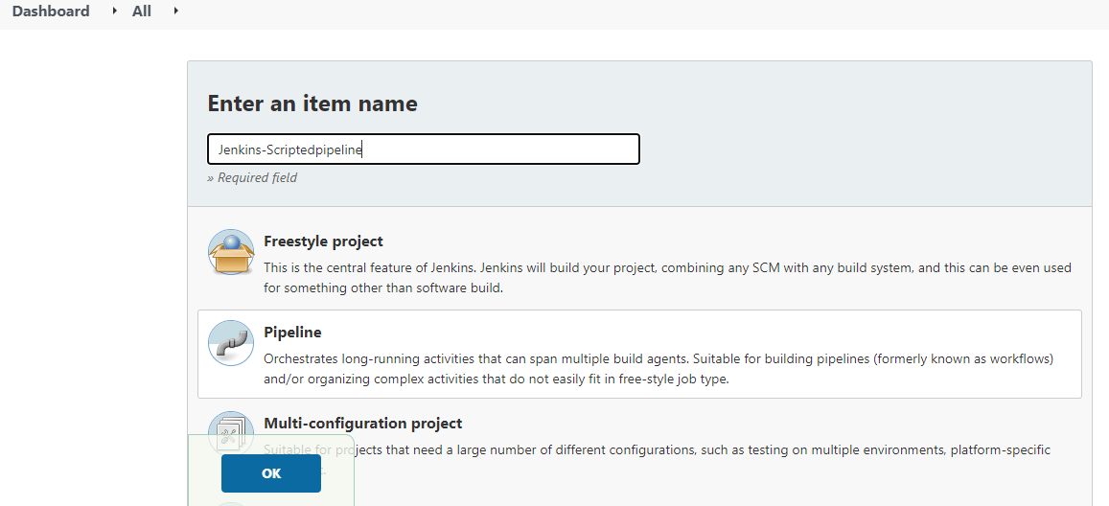



Under pipeline we have Scripted and Declarative Pipelines are there,

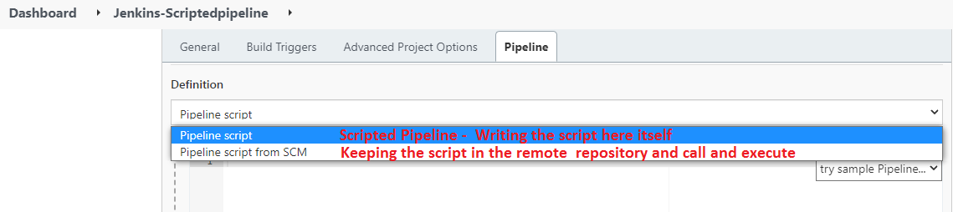

UNDER PIPELINE WRITE GROOVY SCRIPT
SAMPLE CODE WITHOUT ANY COMMAND WE USED SIMPLE SCRIPT TO TEST A PIPELINE: APPLY AND SAVE

node
{
stage('Commit')
{
echo "This is Code Download from GIT Project Repository.................."
}
stage('Build')
{
echo "This is Build project using maven.................."
}
stage('Test')
{
echo "This is Test project Implementation using Selenium................."
}
stage('Release')
{
echo "This is Delivery using Docker......................................"
}
stage('Monitor')
{
echo "This is Application Logs Monitorinig using tool Splunk............."
}
}
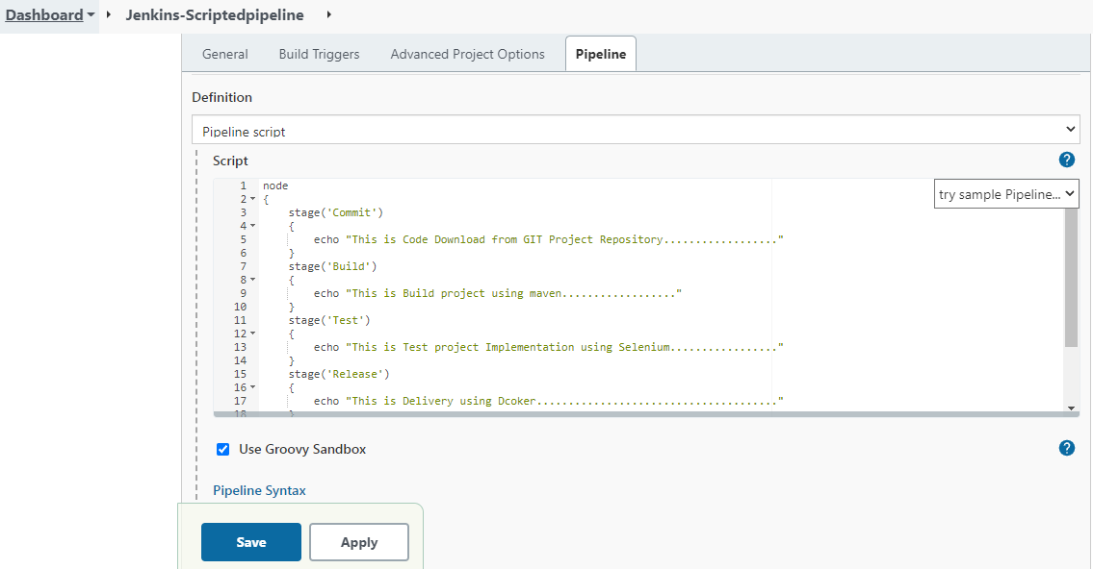


Under pipeline we have Scripted and Declarative Pipelines are there,

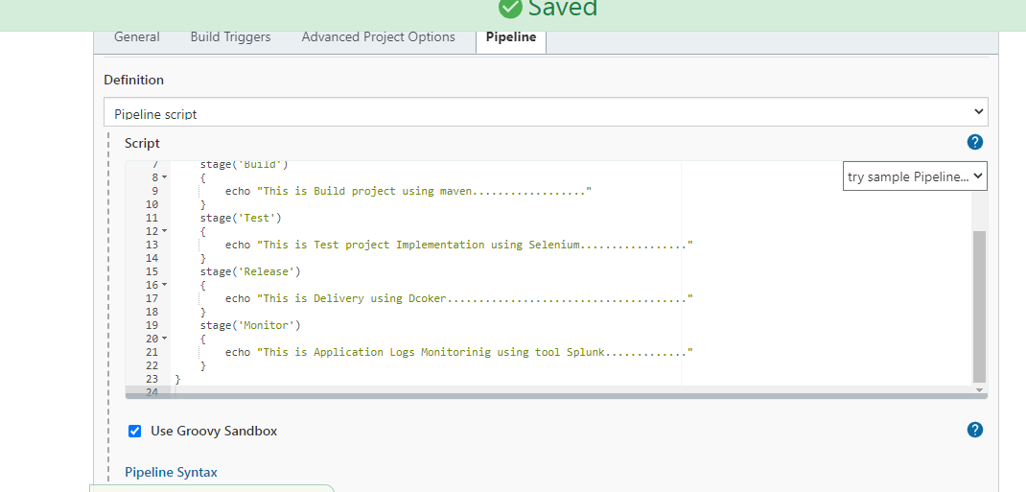

CLICK ON BUILD NOW & VERIFY THE LOGS:
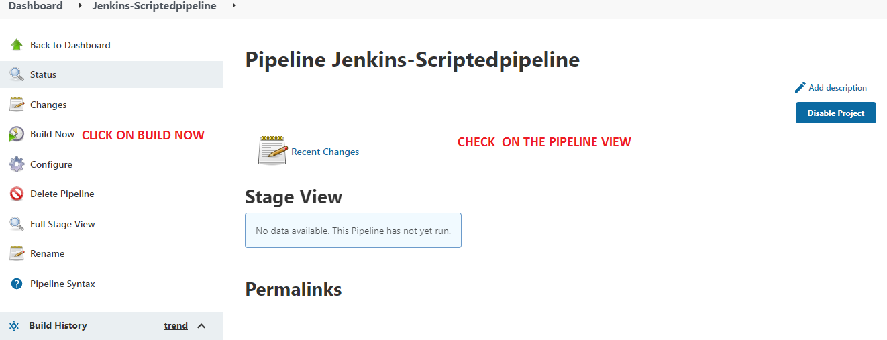

CHECK THE BUILD AND SEE THE VIEW CREATED:
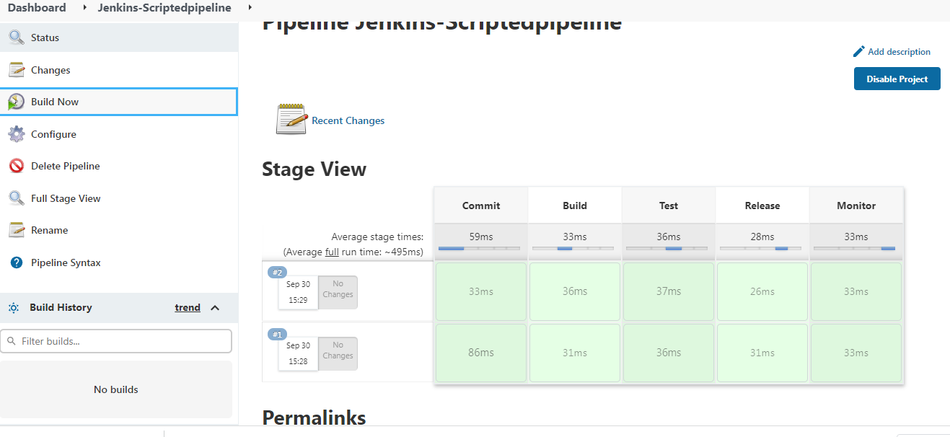


DECLARATIVE PIPELINE:
Jenkinsfile.txt we keep in some remote repository and jenkins would auto-trigger the same and do project run as per the script written.

Create jenkinsfile.txt
Commit jenkinsfile.txt into GITHUB
Integrate GITHUB and JENKINS Using GITHUB plug-in
Then set-up to run the Declarative pipeline

Sample source code:

This may need git knowledge hence showing only the demo that how to do it….

